FINANCIAL MIDTERM REPORT 2020-2021

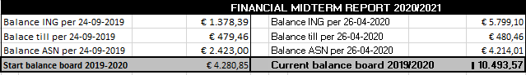

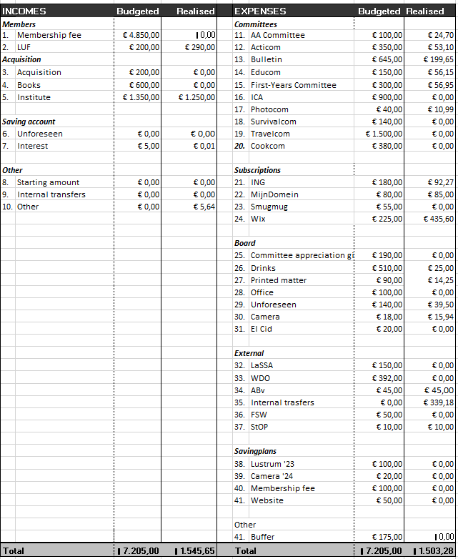

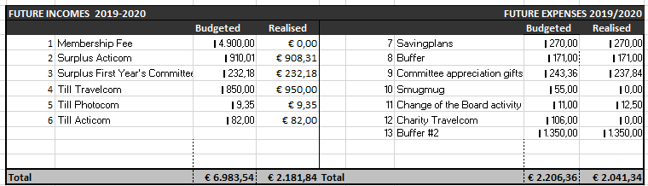

Explanation Financial Midterm Report

INCOMES
Members
- Membership Fee: The contribution will be received in September 2021.
- LUF: This contribution is paid once a year. This year the contribution was higher than budgeted.
ACQUISITION
- Acquisition: This amount consists of an annual contribution from Drukbedrijf Joorit.
- Books: We did not receive money from the February book promotion
- Institute: This concerns the the contribution of the institute to Itiwana, a part of this amount is reserved for the annual study trip. This year, the amount was lower than budgeted.
SAVING ACCOUNT
- Unforeseen: There were no unforeseen incomes this year.
- Interest: This year we received €0,01 interest.
OTHER
- Starting amount: This is the amount that has been saved on the ING account for the last couple of years. This amount has been made fully available to make up for the shortage of acquisitions so that it will not be taken from the committees budgets. None of this has been used yet.
- Internal transfers: Items intended for income that is quickly spent again.
- Other: We received €5,64 of any other income this year. This was from the discarded bank account that has not been used in 24 months. This money is going to ING SPAAR.

EXPENSES
COMMITTEES
- AA Committee: The AA- committee has only spend money on supplies for jewellery.
- Acticom: The Acticom does not have its own bank account yet, so they have not yet received the full budget of Itiwana. Depending on how the expenses this semester will unfold due to COVID-19, a bank account can still be opened.
- Bulletin: This is the amount spend on the first Bulletin.
- Educom: The Educom only made expenses for 2 activities yet.
- First-years Committee: The FYC does not have its own bank account yet, so they have not yet received the full budget of Itiwana. Depending on how the expenses this semester will unfold due to COVID-19, a bank account can still be opened.
- ICA: Because the first ICA has been published online, there have not been any expenses yet.
- Photocom: The photocom has organized one paid activity of €10,99. They received this money from Itiwana.
- Survivalcom: The Survivalcom has not made any expenses yet.
- Travelcom: The Travelcom opened their own bank account, but has not yet received the money of Itiwana due to the uncertain circumstances of COVID-19 around the trip.
- Cookcom: The Cookcom has not made any expenses yet

SUBSCRIPTIONS
- ING: The costs for payment done online.
- Mijndomein: The membership fee to continue to use the emails of Itiwana.
- Smugmug: The website where the photos of Itiwana activities are saved and members can see them.
- Wix: The membership fee for the Itiwana Website. This is a once-in-two-year subscription. It was not budgeted at the beginning of this year, so it will be (re)introduced in the budget from now on. There was no saving plan for it before, so we paid the full membership of €435,60.

BOARD
- Committee appreciation gifts: The gifts for last year’s appreciation gifts is paid.
- Drinks: This money is meant to be spent on the constitution drinks of Itiwana, the lofts and the drinks. However, because of the regulations of COVID-19, a large amount of the budget is not spend yet.
- Printed matter: This concerns the printings of posters, committee information booklets and cobo- and Christmas cards.
- Office: There have not been made any expenses yet for the office.
- Unforeseen: There are some unforeseen costs that had to be paid. This mainly concerns costs associated with the merchandise of September 2020.
- Camera: The camera insurance for this year is paid.
- El Cid: This will only apply at the end of the year

EXTERNAL
- LaSSA: This concerns the annual contribution to the national study association anthropology students. It has not been paid yet.
- WDO: WDO receives an amount from Itiwana according to the distribution key of 9% of the contribution. This amount has not yet been transferred.
- ABv: By transferring the contribution from the Abv, this amount was paid for the contribution of 2019.
- Internal transfers: Items for expenses that will be paid back soon. This includes the money for the Doppers for the clothing line and the double contribution payment of the ABv.
- FSW: This money is intended for activities organized in collaboration with the study associations of the FSW.
- 37: StOP: This concerns the annual contribution to the Studenten Overleg Platform

SAVINGPLANS
- Saving plans: The money for the saving plans will be set aside at the end of the year if the funds for this are released.
- Idem.
- Idem.
- Idem.
OTHER
- *Buffer: The money for the buffer will be set aside at the end of the year if the funds for this are released.
*The buffer will be used to change the contribution system as well. Due to the lack of money being spend on activities this year, the money that is saved will be used to make this change happen.

FUTURE INCOMES 2020/2021
- Membership fee: The membership fee will happen at the end of this year.
- Suprlus Acticom: The amount of money that came in from the prom as well as the amount of money the Travelcom raised for charity. It was slightly less than budgeted.
- Surplus First Year’s Committee: The amount of money that was left over at the end of last year.
- Till Travelcom: Amount of money left over from the Travelcom last year. It was higher than the budgeted.
- Till Photocom: Amount of money left over from the Photocom at the end of last year.
- Till Acticom: Amount of money left over from the Acticom at the end of last year.

FUTURE EXPENSES 2019/2020
- Savingplans: The savingplans have been transferred to the saving account.
- Buffer 1: The amount of money that was left over due to COVID-19. This money has been transferred to the savings account.
- Committee appreciation gifts: This amount was lower than the budgeted amount.
- Smugmug: SmugMug has not been paid yet.
- Change of the board activity: This amount was slightly higher than the budgeted amount.
- Charity Travelcom: This money has been transferred to the Itiwana bank account (together with the surplus of Acticom).
- Buffer 2: The amount of money that was left over due to COVID-19. This money has been transferred to the savings account.

COMMITTEES
AA- COMMITTEE
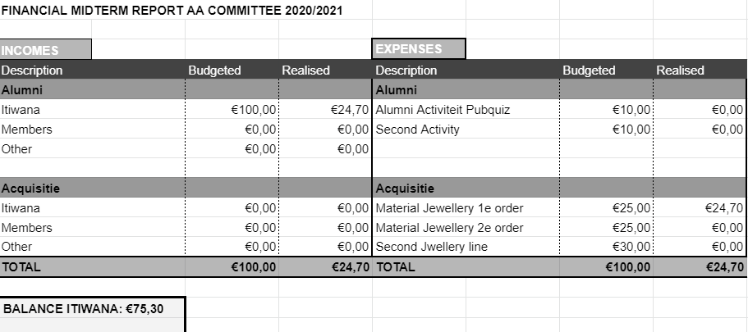

ACTIVITIES COMMITTEE
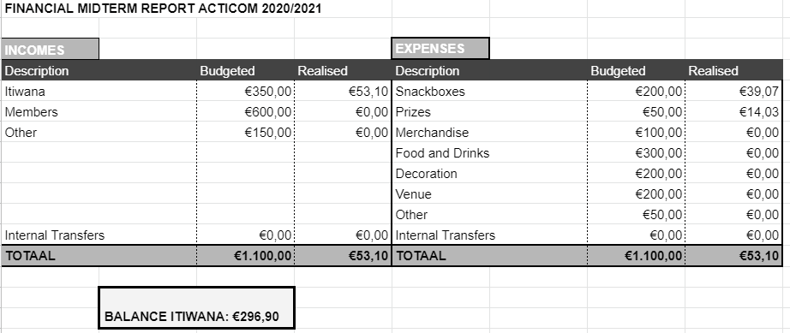

BULLETIN
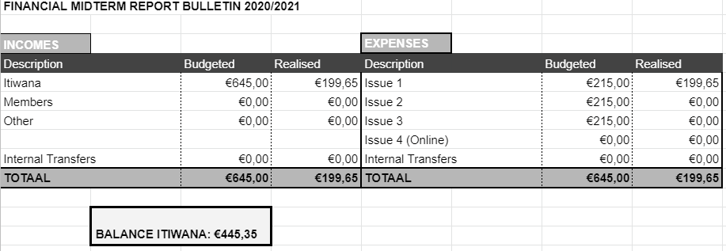

EDUCATION COMMITTEE
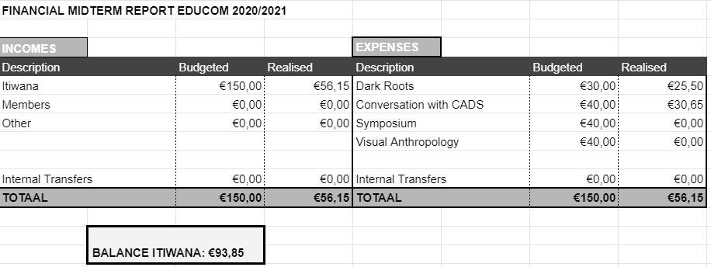
FIRST YEARS COMMITTEE
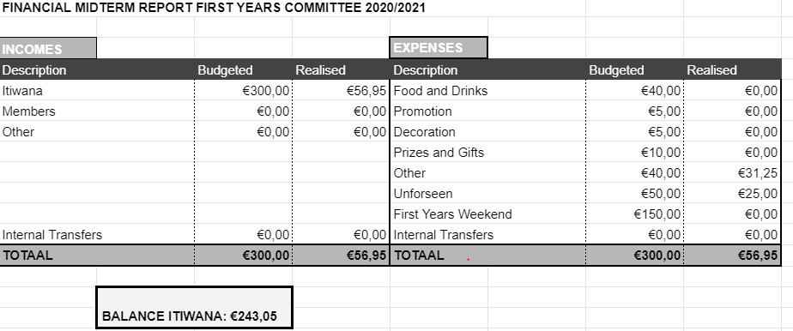

ICA
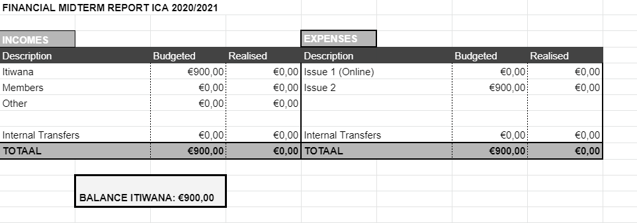
PHOTOCOM
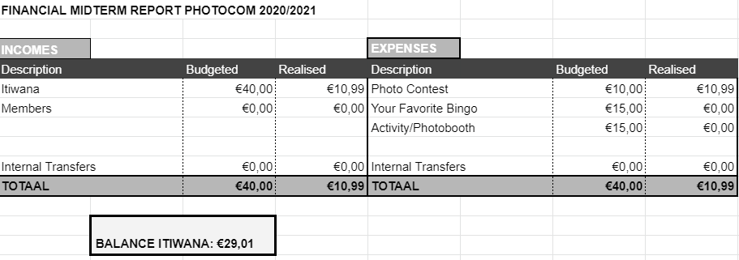

SURVIVALCOM
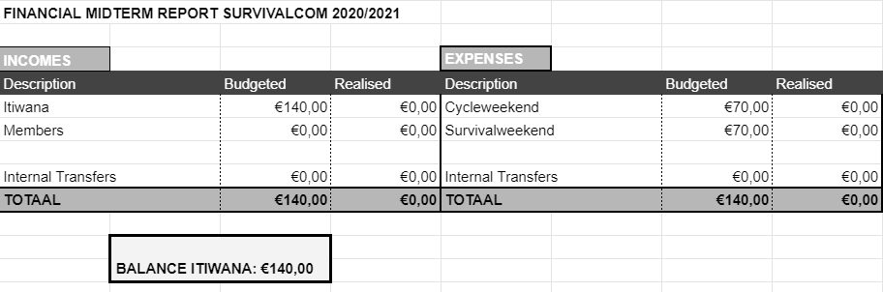

TRAVELCOM
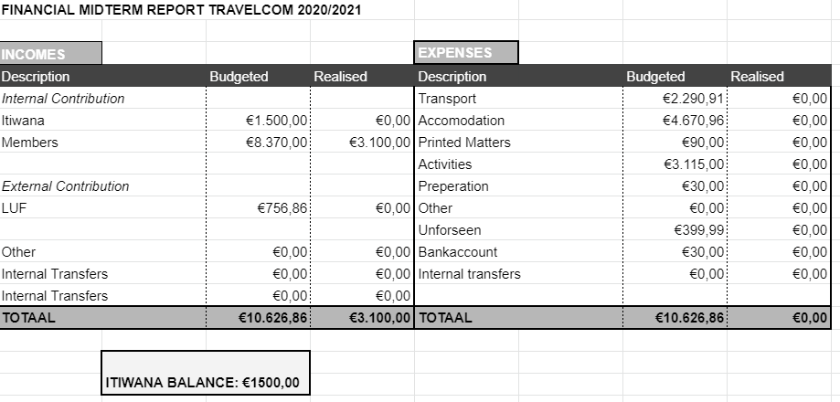

COOKCOM
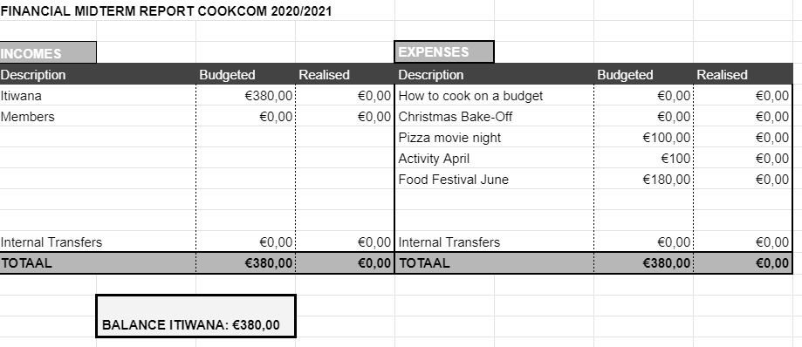

LaSSA
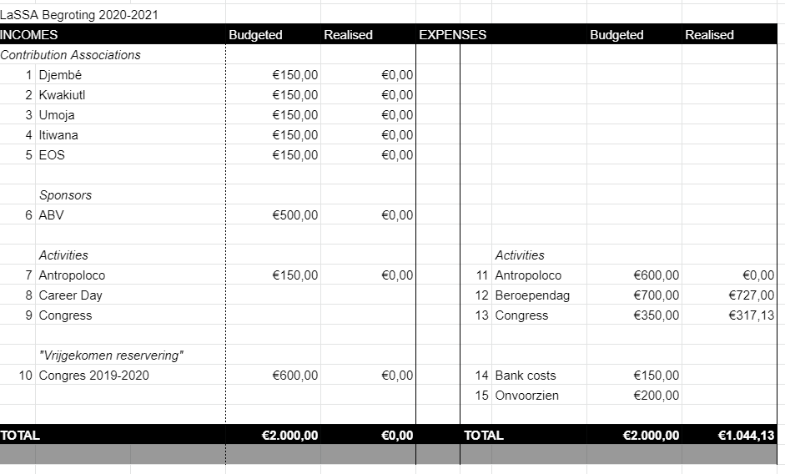
INCOMES
LaSSA receives contribution from every anthropology study association in the Netherlands as well as from the ABV, the anthropological career association.
EXPENSES
11. Antropoloco is a festival that will be held at the end of the year.
12. The career day: shows anthropology students what kind of career paths they can take. This year, the theme of this career day was Art & Anthropology.
13. Congress: Enables interesting speakers to inspire the students. The theme of this year was Positivity.

